Some Approaches to Best-Match File Searching
W.A. Burkhard and R.M. Keller
Communications of the ACM Vol. 16 No. 4 p230-236, April 1973

Abstract
The problem of searching the set of keys in a file to find a key which is closest to a given query key is discussed.

1.Introduction
Suppose that X is file, each member of which is indexed by a key, and q is a query key possibly not in the file. There are three types of searches through file X.
2.Search Techniques for classes 1 and 2
a. File Structure 1.Pick a n arbitrary element 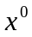 of X. Then divide X – {} into subsets 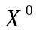,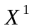,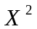,…,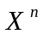 where for all k = 0,1,..,n and all x 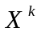,d(x, ) = k.

Search Algorithm 1.
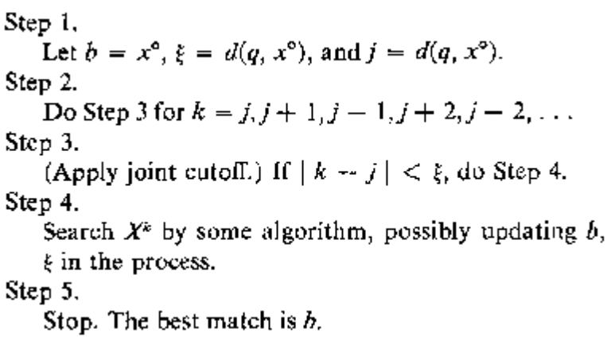

b. File Structure 2.Divide X into a number of sets ,,,…,
such that for each i = 1,2,…,n there is a key 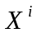 and a number 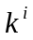 such that for each x , d(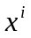,x)

Search algorithm 2.
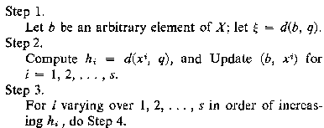
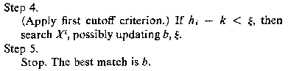
c. File Structure 3.Find a set C = {,,…} of cliques such that every key in X is in at least one element of C.
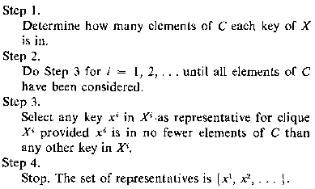
Search Algorithm 3.
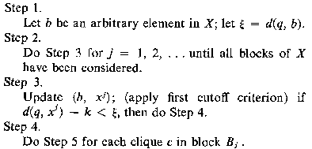
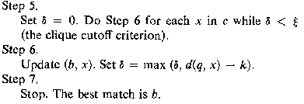
3.Conclusons
There are some unanswered questions can be continued.
- How much of an average file can be eliminated using cutoff criteria?
- Is it possible to take into account additional knowledge of the contents of the file and thereby “do better” than in the average case?
- Are there other clustering techniques which do as well as or better than the two mentioned here?

Created by: Chia-Chung Wang
Date: April 30, 2003

